HERO SECTION

Ecommerce Fulfillment Europe — Powered from the Netherlands
Running a successful online store goes beyond selling — it’s about delivering fast, accurately, and consistently. We help ecommerce brands streamline their operations with reliable ecommerce fulfillment services in Europe, so you can focus on growth while we handle the logistics.
From advanced inventory management to fast and reliable shipping, our solutions are built to support your expansion across Europe.
Request a Quote

Your Webshop, Our Responsibility
Managing logistics in-house slows growth and increases complexity. As a leading provider of 3PL fulfillment in Europe, we simplify your operations with fully managed solutions — including storage, order processing, and shipping.
Focus on scaling your business while we handle your fulfillment.

Reliable Logistics Network Across Europe
Our strong network of logistics partners enables fast and efficient cross border fulfillment Europe. We connect your store with trusted shipping providers to ensure consistent delivery performance. Whether you need shipping and fulfillment services or a complete inventory management and order fulfillment setup, we’ve got you covered.

Scalable Warehouse Infrastructure
Access over 250,000 m² of warehouse space, including a strategically located fulfillment center in the Netherlands.
From startups to high-volume ecommerce brands, our infrastructure scales with your growth.

Real-Time Visibility & Control
Stay in control of your operations with a powerful dashboard that gives you real-time insights into:
- Inventory levels
- Order processing
- Shipment tracking

Accuracy You Can Rely On
We maintain a 99.97% order accuracy rate, ensuring every order is picked, packed, and shipped with precision. Our experienced team focuses on delivering a seamless experience for your customers.

Why Choose Us

Smart Technology That Scales
Our advanced software integrates seamlessly with your ecommerce platform, making ecommerce fulfillment in Europe efficient and scalable.

Focus on Growth
We handle your logistics so you can focus on marketing, sales, and expansion.

Faster European Shipping
With fulfillment centers across Europe, we reduce delivery times and improve customer satisfaction.

Seamless Integrations
Connect with Shopify, WooCommerce, and more for automated fulfillment workflows.
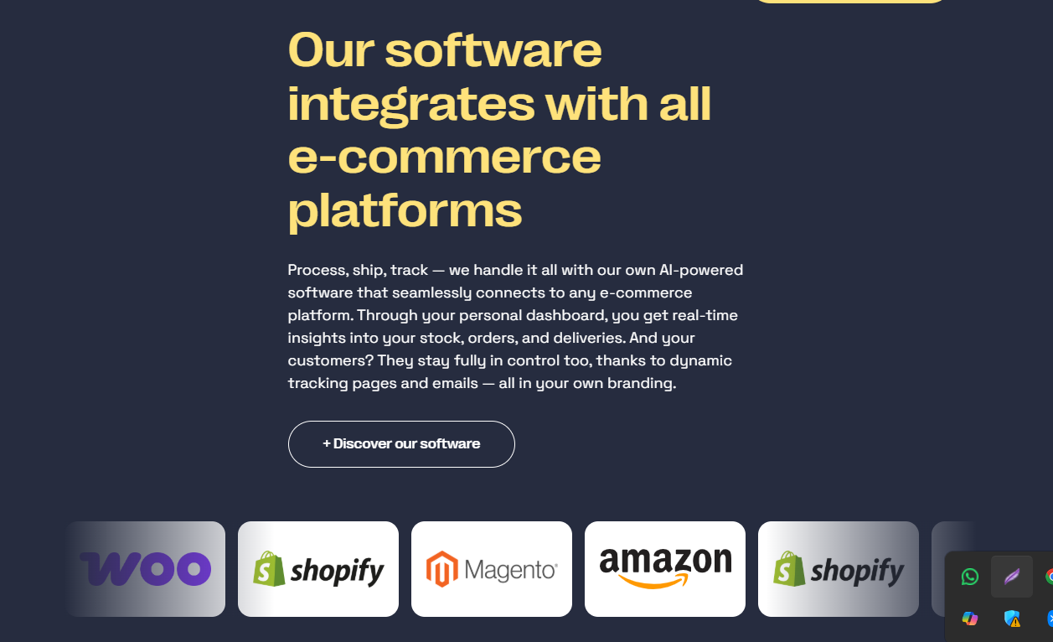
Note: We will not change in this section because it's already perfect !

What We Offer
Experienced Ecommerce Team: Our team understands ecommerce logistics Europe, ensuring your operations run efficiently.
Technology-Driven Fulfillment: We use a smart order fulfillment system to deliver reliable solutions across the continent.
Specialized B2B Solutions: We offer dedicated B2B fulfilment services tailored for large-scale distribution.

Global Fulfillment Network
We operate fulfillment centers and logistics hubs across:
- Netherlands
- Germany
- Spain
- United Kingdom
- United States

Ready to Scale Your Ecommerce Business?
Looking for a reliable fulfillment partner in Europe or a scalable 3PL provider in the Netherlands?
Grow faster, reduce operational complexity, and deliver a better customer experience.
Request Your Quote Today

